# CAR BOOKING RESERVATION SYSTEM

**STEP – 1:**

Create a new application.

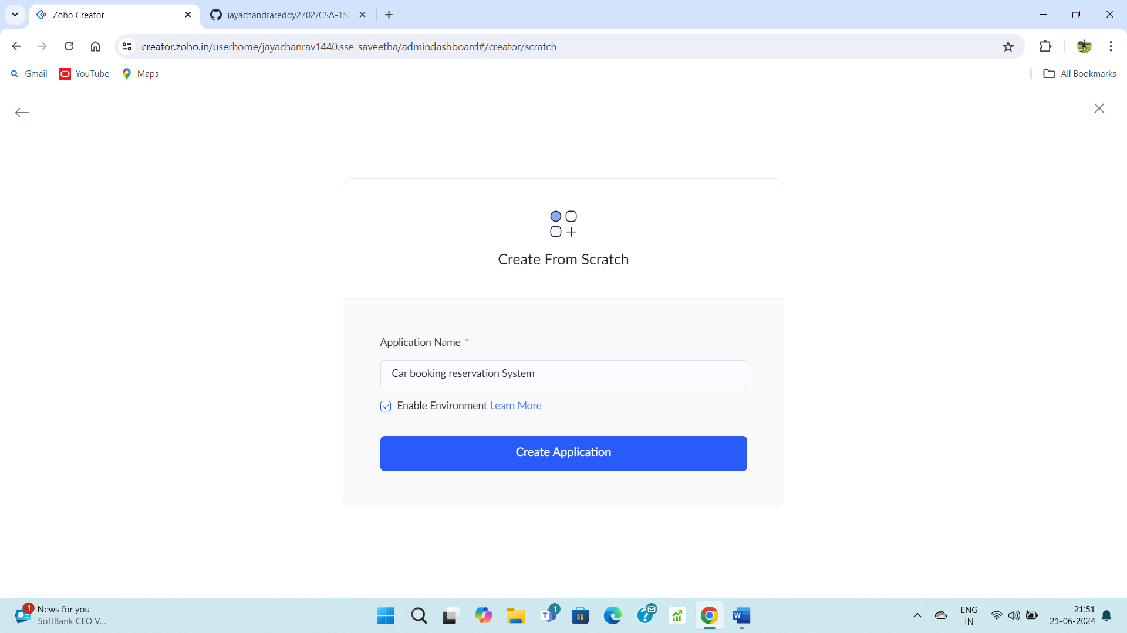

**STEP – 2:**

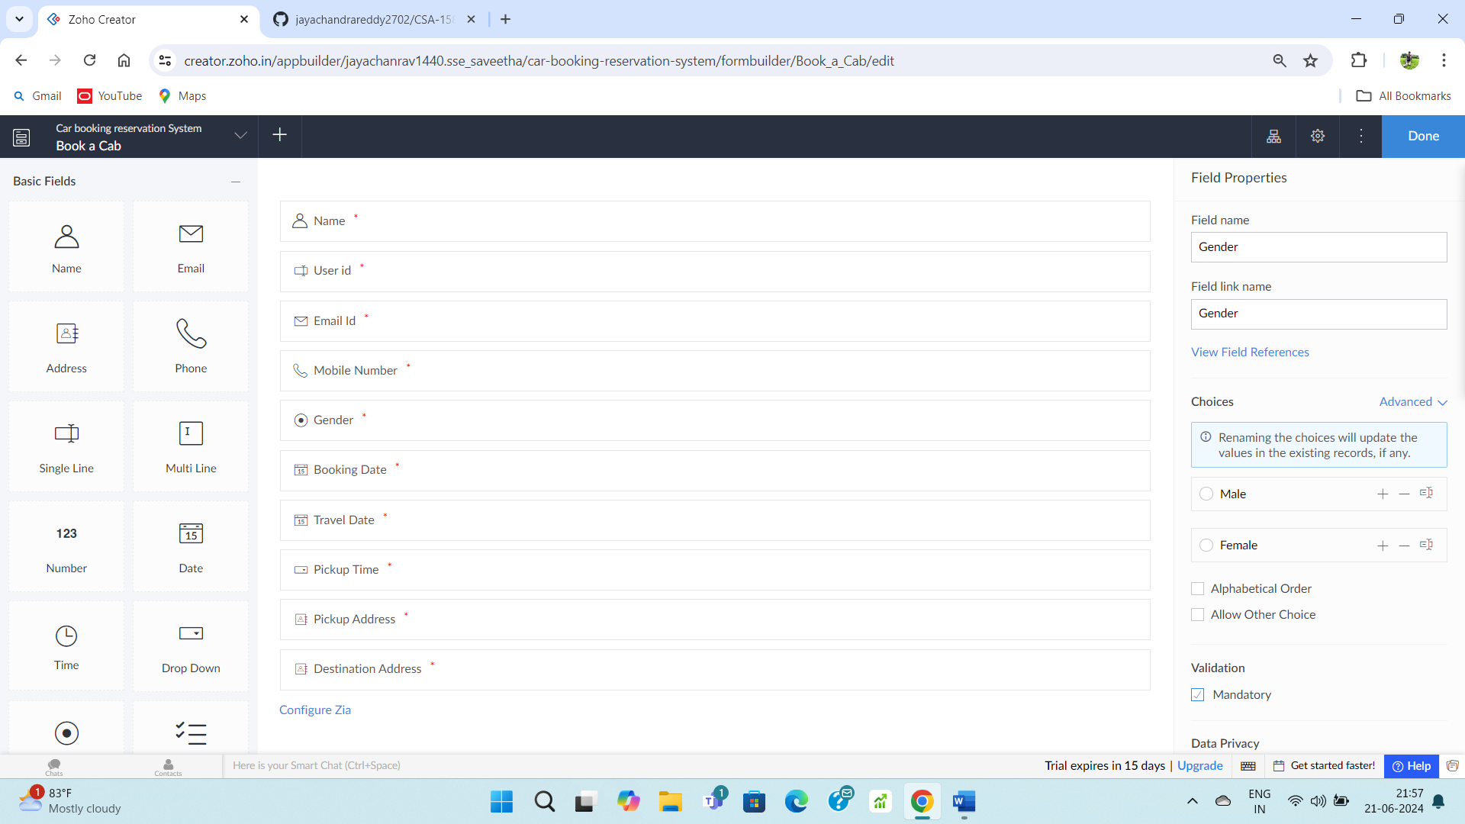

**STEP – 3:**

Fill upon the created form.

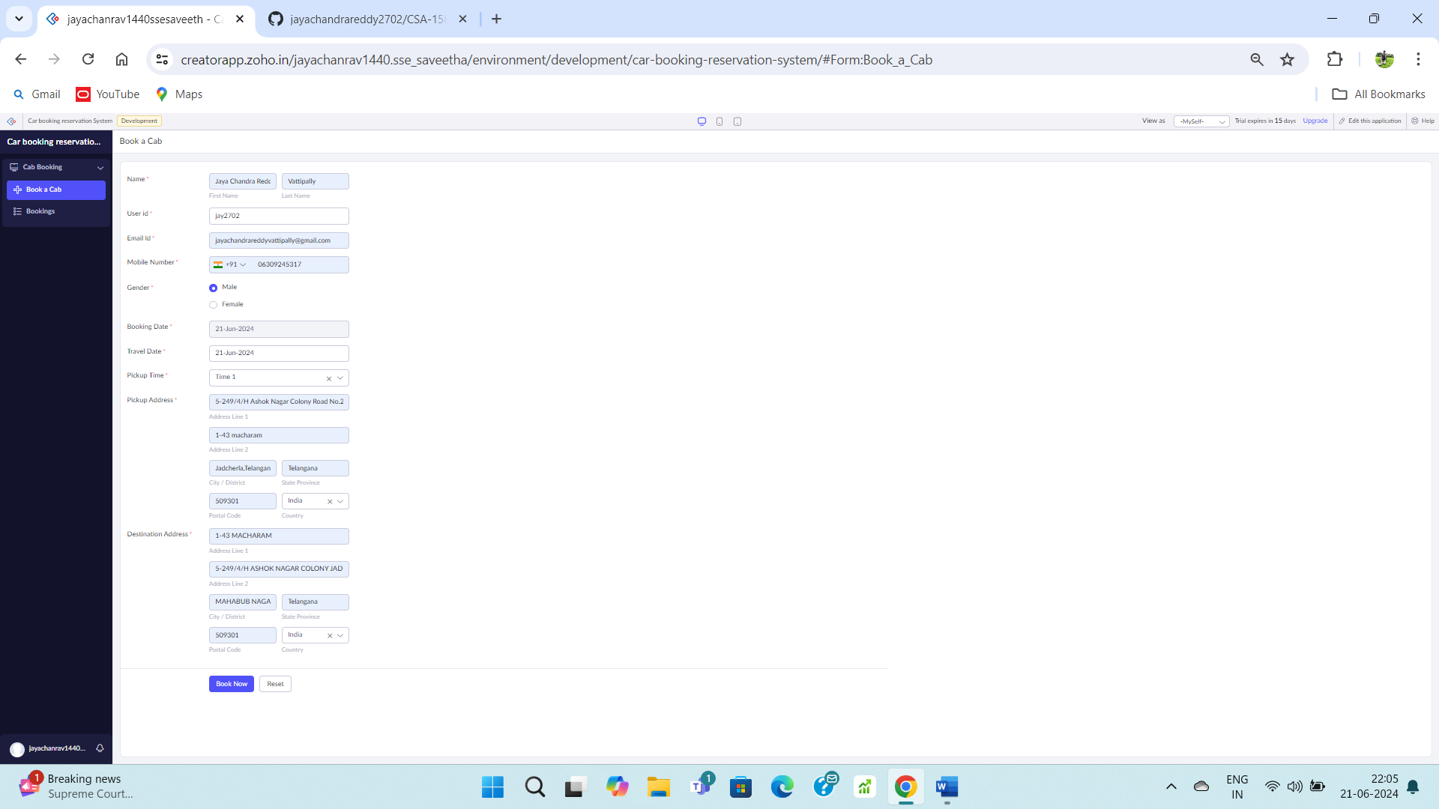

**STEP – 4:**

Go to login report form.

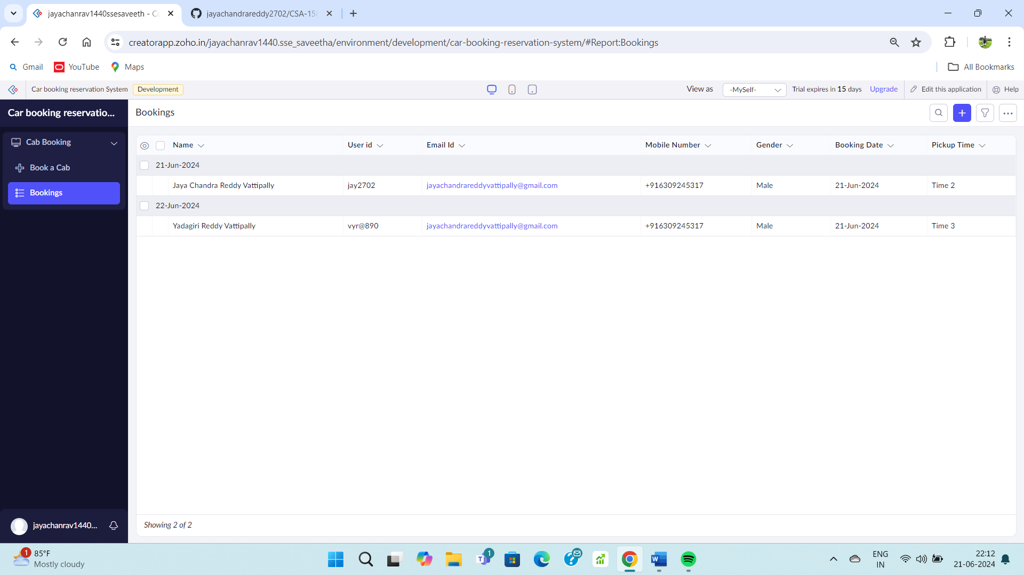

**STEP – 5:**

Create a payment form.

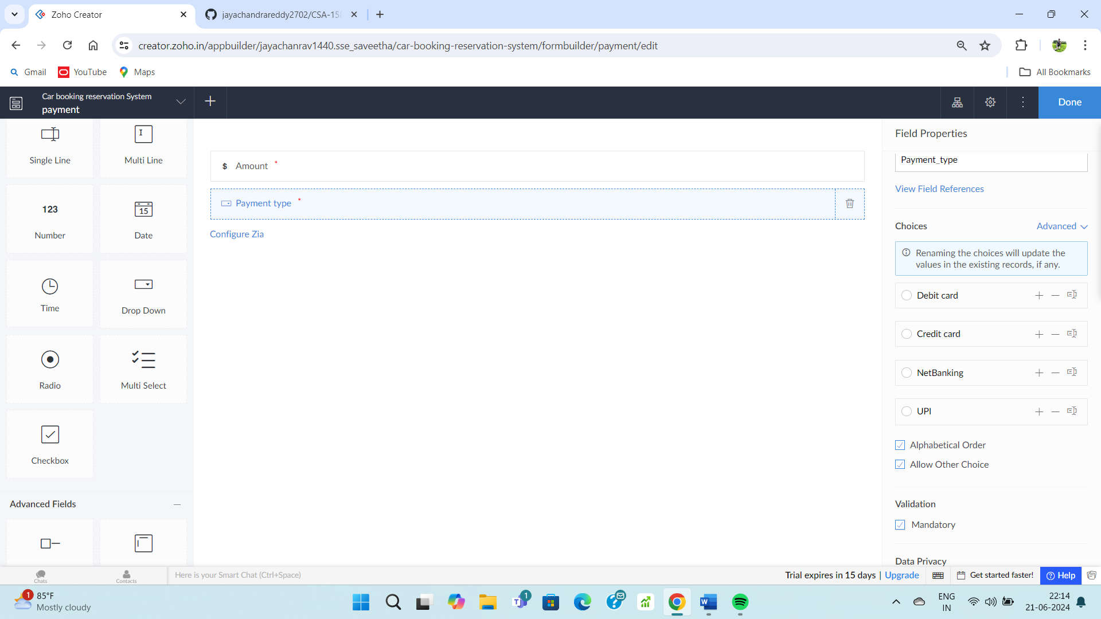

**STEP – 6:**

Fill up on the created form.

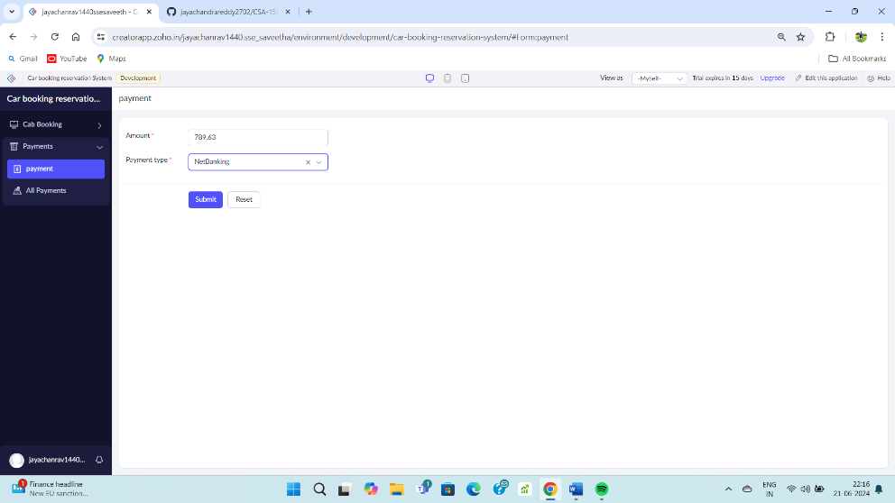

**STEP – 7:**

Go to payment form.

